

**Runbook - Webservice testing GoRest**

Contents

1.0 About this Guide 2

2.0 Pre-requisite 2

3.0 Required Files/Folders 2

4.0 Data table configuration 3

5.0 Test case creation 3

6.0 Test case execution 4

7.0 Execution report 5

# About this Guide

This document illustrates the utilizing the web services automation framework which has been integrated with TestNG.

# Pre-requisite

* Need to install have eclipse with TestNG and Maven installed.
* Imported as Maven project.
* Maven POM.xml should have required dependencies like TestNG, extent report and apache POI.

# Required Files/Folders

Folder and files should be available as shown below.

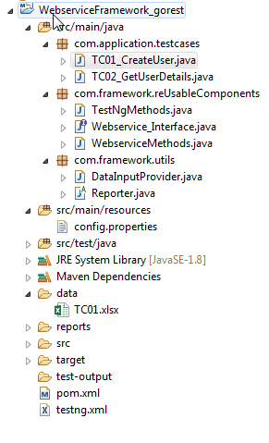

# Data table configuration

Data table should be filled as shown below.

* We need to provide the below items.
  + Endpoint - Url
  + Httpmethod – need to mention whether get or post.
  + Parameters – if required key and values should be separated by semicolon(;)
  + Headers – if required key and values should be separated by semicolon(;)
  + Authorization – if required key and value should be separated by semicolon(;)
  + Request body – Request body content should be provided.
  + UserID – should be provided for getting user details validation (TC02).



# Test case creation

Test cases should be created in the path **src/com.application.testcases. Also the class should extend the reusable class.**

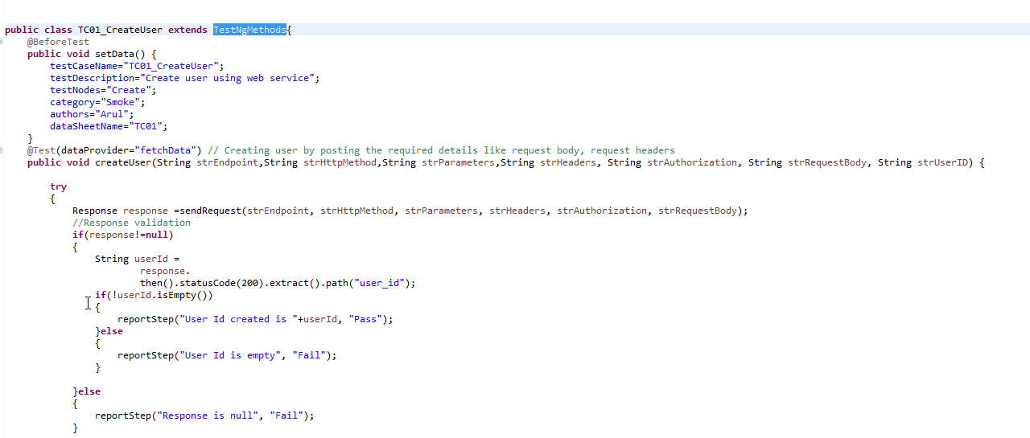

WebserviceMethods.java class will have a generic reusable method which will send the web service request and return the response. WebserviceMethods class implements a interface.

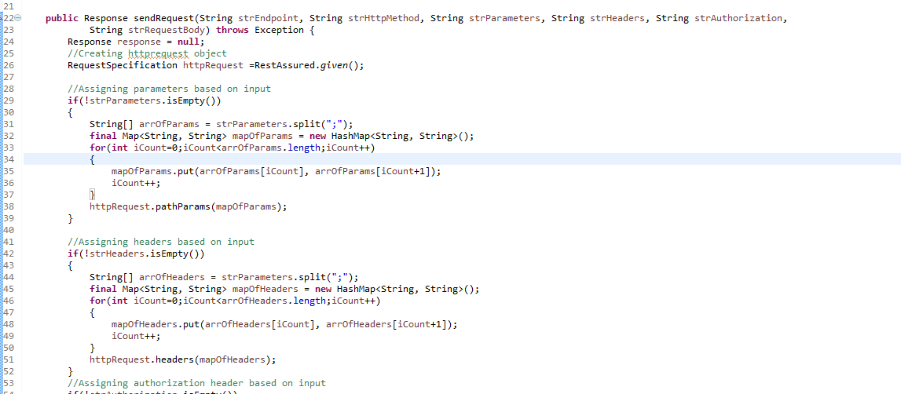

# Test case execution

* We need to create a testing suite as xml file by below steps.
  + Right clicking on the project and select convert as TestNG

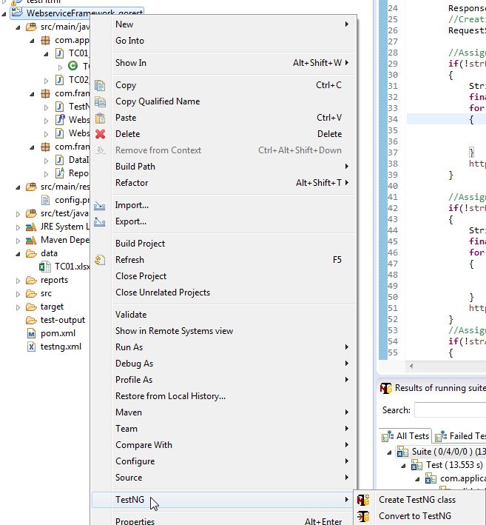

* Once the xml is created, right click on the xml and select Run as TestNG suite.

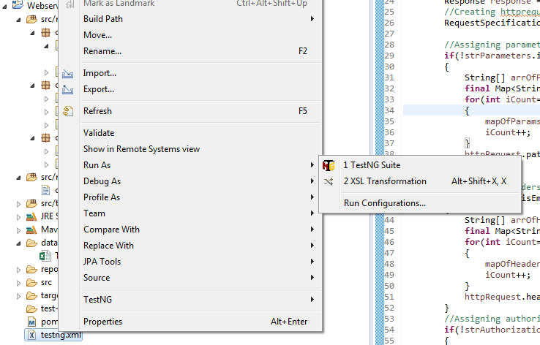

# Execution report

We have utilized extent report and implemented the reporting part to produce html.

Repots will be generated in separated folder called reports.

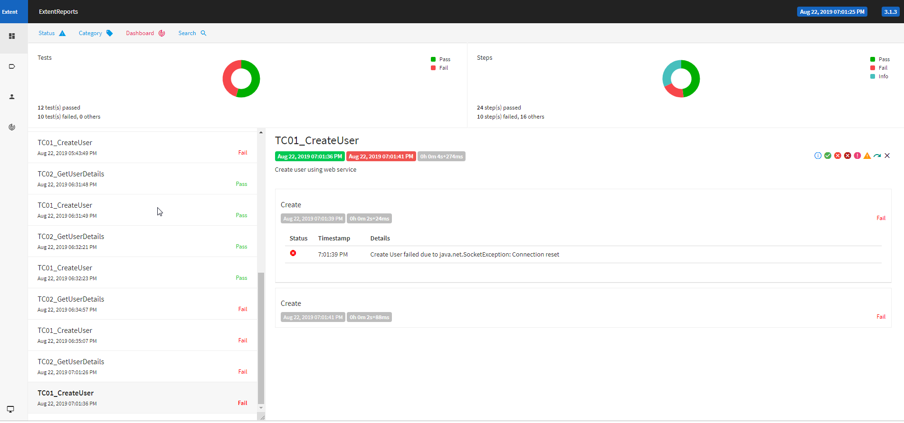

Contact: [Prakash.arul87@gmail.com](mailto:Prakash.arul87@gmail.com)